**PROJECT REPORT TEMPLATE**

**1.INTRODUCTION**

Business cards serve as a convenient way to exchange essential information during professional networking, making a lasting first impression. They are often designed to reflect a person’s organization’s branding, and they can also include logos, social media profiles, and a brief tagline or description.

**OVERVIEW**

The project aims at creating professional business cards using Canva application, as a straight forward process. Canva makes the process of creating professional- looking business cards easy and accessible, even for those with little design experience.

**PURPOSE**

Canva offers various design templates and customization options, making it user-friendly for students to create visually appealing and professional business cards for class projects, job search, personal branding, and internship purposes.

**2.PROBLEM DEFINITION AND DESIGN THINKING**

**(i) EMPATHY MAP**

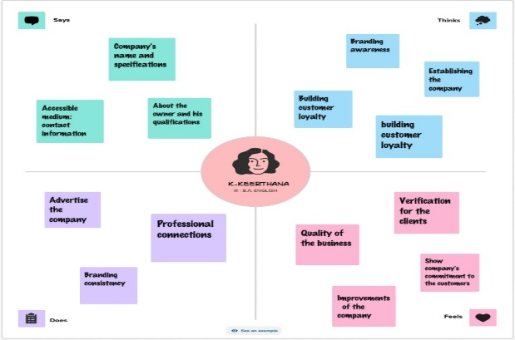

**(ii) BRAINSTORMING MAP**

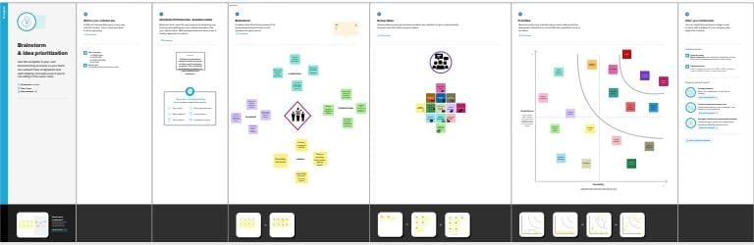

**3.RESULT**

Personalized business cards remain a valuable and timeless tool for marking connections and leaving a lasting impression in the business world. Designing your own professional business cards can extend beyond just sharing contact information, contributing to your overall brand image and success in networking and business relationships.

** **

**4. (i)ADVANTAGES**

* Networking with potential business clients
* Helps to maintain brand identity and credibilty
* Marketing tool which provides contact information

**(ii)DISADVANTAGES**

* Limited space and information
* Outdated information resulting in misleading clients
* Digital preference and limited marketing

**5.APPLICATIONS**

* Professionals exchange business cards during meetings, conferences
* Entrepreneurs promote their businesses or products
* Sales representatives share contact information
* Tour operators, hotels promote their services to tourists and travellers

**6.CONCLUSION**

Creating our business cards allows us to express our individuality and ensures brand identity. Canva application is a valuable tool for individuals and small business looking for a convenient and cost-effective way to create professional business cards and other marketing materials.